Basic Linux Commands

*Question 1 and 2*

* -Touch-create file,
* -echo-write in a file
* -cat -display

*Question 3*

* Mv – command to rename file

Question 4

* cp – copy file to another file

*Question 5.*

* Ls b\*.txt – list all files starting with b and extension txt

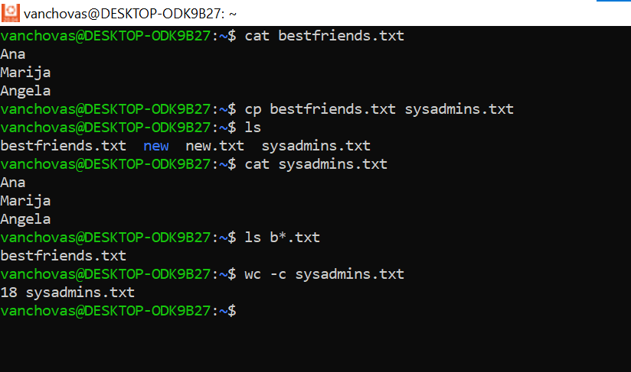

*Question 6*

* Wc -c - byte count in a file

*Question 7*

* Touch – create file
* Echo – write in file

*Question 8*

* Wc -c – bytes in a file

*Question 9*

* Mkdir – make directory
* Cd – change directory
* Ls -la – list all files in direcory
* Cd .. – go back one level (get out of tmp go to root)

*Question 9*

**

*Question 10*

* Cp cars.txt tmp – copy a file into a directory
* Ls \*.txt– see if cars is copied in tmp
* Cat – see content of cars.txt

*Question 11*

* Mv – source directory/file destination directory/file to rename a file into different direcory

*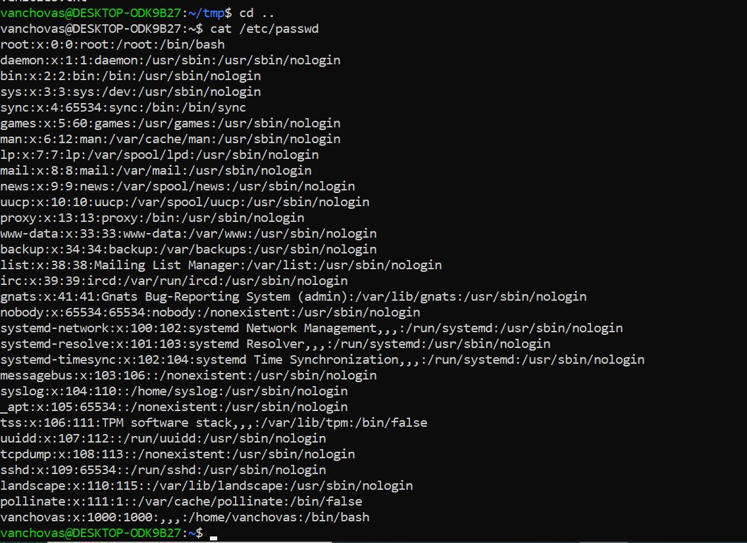*

*Question 12*

* Cat /etc/passwd – display content of /etc/passwd